Tutorial 6

1. Write a database description for each of the relations shown, using SQL DDL (shorten, abbreviate, or change any data names, as needed for your SQL version). Assume the following attribute data types:

StudentID (integer, primary key), StudentName (25 characters), FacultyID (integer, primary key), FacultyName (25 characters), CourseID (8 characters, primary key), CourseName (15 characters), DateQualified (date), SectionNo (integer, primary key), Semester (7 characters)

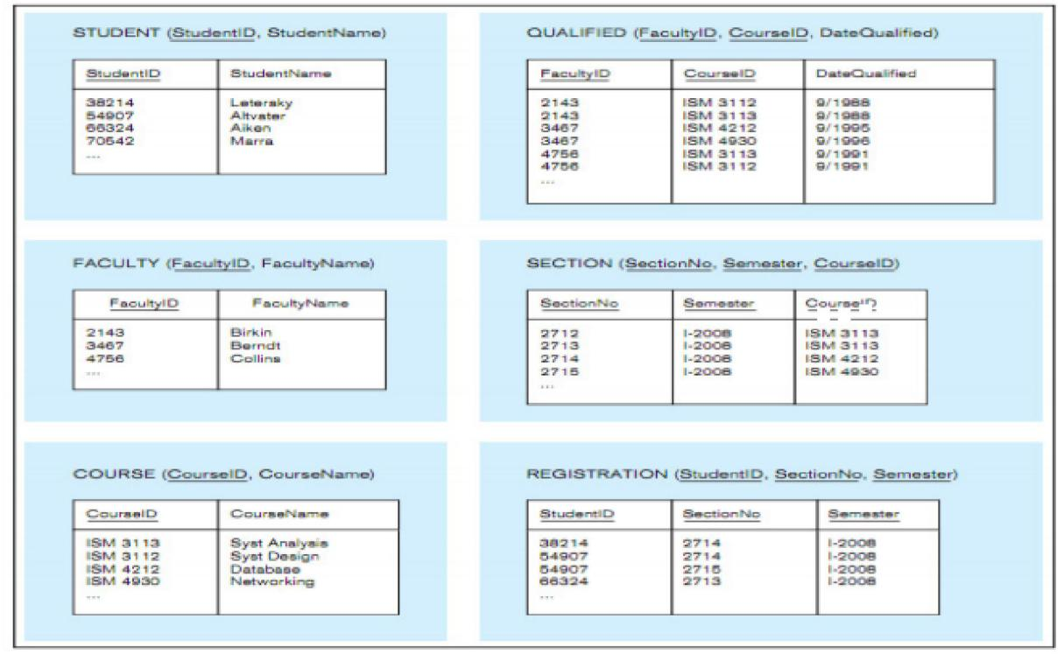

FROM Question >=2, use table above to write SQL Query, Faculty has the same meaning as Instructor.

2. Create an SQL VIEW for following table

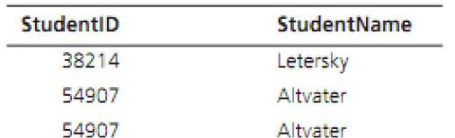

3. Write SQL data definition commands for each of the following queries:

a. How would you add an attribute, Class, to the Student table?

b. How would you remove the Registration table?

c. How would you change the FacultyName field from 25 characters to 40 characters?

1. Write SQL commands for the following:

a. Create two different forms of the INSERT command to add a student with a student ID of 65798 and last name Lopez to the Student table.

b. Now write a command that will remove Lopez from the Student table.

c. Create an SQL command that will modify the name of course ISM 4212 from Database to Introduction to Relational Databases.

5. Write SQL queries to answer the following questions:

a. Which students have an ID number that is less than 50000?

b. What is the name of the faculty member whose ID is 4756?

c. What is the smallest section number used in the first semester of 2008?

6. Write SQL queries to answer the following questions:

a. How many students are enrolled in Section 2714 in the first semester of 2008?

b. Which faculty members have qualified to teach a course since 1993? List the faculty ID, courseID, and date of qualification.

7. Write SQL queries to answer the following questions:

a. Which studentsID are enrolled in Database and Networking? (Hint: Use SectionNo for each class so you can determine the answer from the Registration table by itself.)

b. Which instructors teach both Syst Analysis and Syst Design?

8. Write SQL queries to answer the following questions:

a. What are the courses included in the Section table? List each course only once.

b. List all students in alphabetical order by StudentName.

c. List the students who are enrolled in each course in Semester I, 2008. Group the students by the sections in which they are enroll